

PANDA BOOK STORE

**PROJECT REPORT**

**18CSC310J – DATA CENTRIC NETWORKING AND SYSTEM DESIGN**

**(2018 Regulation)**

**III Year/ V Semester Academic Year: 2022 -2023** By

**S.M.DINESH (RA2011028010057)**

**KARTHI. C (RA2011028010072)**



**FACULTY OF ENGINEERING AND TECHNOLOGY SCHOOL OF COMPUTING**

**SRM INSTITUTE OF SCIENCE AND TECHNOLOGY**

**Kattankulathur, Kancheepuram NOVEMBER 2022**

**BONAFIDE**

This is to certify that the project report titled “PANDA BOOK STORE” is the bonafide work of **S.M.DINESH (RA2011028010057), KARTHI. C (RA2011028010012)** who undertook the task of

completing the project within the allotted time.

**Signature of the Course Faculty**

SAVEETHA D

**Assistant Professor** Department of NWC,

SRM Institute of Science and Technology

**ABSTRACT**

Panda book store is a website which makes the selling of books to customers at optimal pricing and also allows the customers to take in e-books. Our website allows to have preface of the books as this make the whole buying process even more effective.

Main idea is to host our dynamic website on an amazon ec2 instance.

As we lack adequate computing resources amazon ec2 instance was optimal to the project’s scope. As amazon’s ec2 instance allows users to scale up their resources when in need. We are using XAMPP software for hosting the website.

XAMPP is a [free and open-source](https://en.wikipedia.org/wiki/Free_and_open-source) [cross-platform](https://en.wikipedia.org/wiki/Cross-platform) [web server](https://en.wikipedia.org/wiki/Web_server) [solution](https://en.wikipedia.org/wiki/Solution_stack)

[stack](https://en.wikipedia.org/wiki/Solution_stack) package developed by Apache Friends, consisting mainly of the [Apache](https://en.wikipedia.org/wiki/Apache_HTTP_Server) [HTTP Server](https://en.wikipedia.org/wiki/Apache_HTTP_Server), [MariaDB](https://en.wikipedia.org/wiki/MariaDB) [database](https://en.wikipedia.org/wiki/Database), and [interpreters](https://en.wikipedia.org/wiki/Interpreter_(computing)) for scripts written in

the [PHP](https://en.wikipedia.org/wiki/PHP) and [Perl](https://en.wikipedia.org/wiki/Perl) [programming languages](https://en.wikipedia.org/wiki/Programming_language). Since most actual web server deployments use the same components as XAMPP, it makes transitioning from a local test server to a live server possible.

This model allows us to give the clients have an good experience and also a swift backend to power then user interface at a cost efficient pricing model.

**Table of Contents**

|  |  |  |
| --- | --- | --- |
| **Chapter No** | **Name** | **PageNo** |
| **1** | **Introduction** | **5** |
| **2** | **System Design** | **7** |
| **3** | **Implementation** | **10** |
| **4** | **Conclusion** | **18** |

**Introduction**

When a client tries to access our website at first it will ask for user registration followed by creation of an account, which the user will use to purchase the books online and also access the website according to his preferences. And then those credentials are stored in the database (XAMPP) in order to support the user interface. Which will also take care the transaction controls of the database. Our main objective is to host the website using an ec2 instance as a host machine.

This could be done via the traditional method where we configure a particular domain for the website and with the help of server farms the website will be deployed to the internet. The server will help the website backend to process the user requests and the manage if there is spike in users accessing the website. There should a proper database maintained to store all of the user credentials and proper database design planning must be done to ensure the database integrity and the access controls. This traditional method will cost more money and lot of maintenance works, and professionals to make this work. This could be done on a group or local area network, because this will hinder with the database shortage and also jeopardizes the whole project plan.

Moving to cloud would be a viable option because cloud offers a lot more models with appropriate pricing model, basic and more crucial works like server maintenance is now taken care by the cloud service providers which makes the employers free from works.

There are lot of drawbacks with the traditional methods. They are not cost effective and components like server farms and maintenance professionals are costly in order to hire and train them. For hosting such a dynamic website will take a lot of computing components and a high-end database to co-ordinate and support the user interface, which are most costly when it comes to the start-up phase of any company or any individual.

As the traditional methods does not provide the optimal solution as cloud models provide, we decided to host our dynamic website in cloud, as we lack adequate computing resources amazon ec2 instance was optimal to the project’s scope. As amazon’s ec2 instance allows users to scale up their resources when in need. This will also hinder with the storage space we have at present.

To solve these issues, we decided to host our dynamic website in the amazon ec2 instance as this is scalable according to our demands, and also is way much cost effective than opting for the traditional method. Our objective is to deploy our website using and ec2 instance and ensure the support of the backend to the user interface in order to deliver proper user experience.

**Chapter 2**

**System Design**

* 1. **Architecture Diagram**

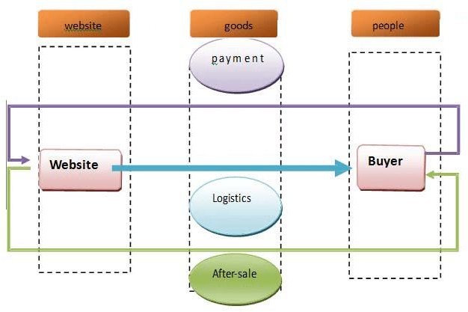

* 1. **Use case diagram**

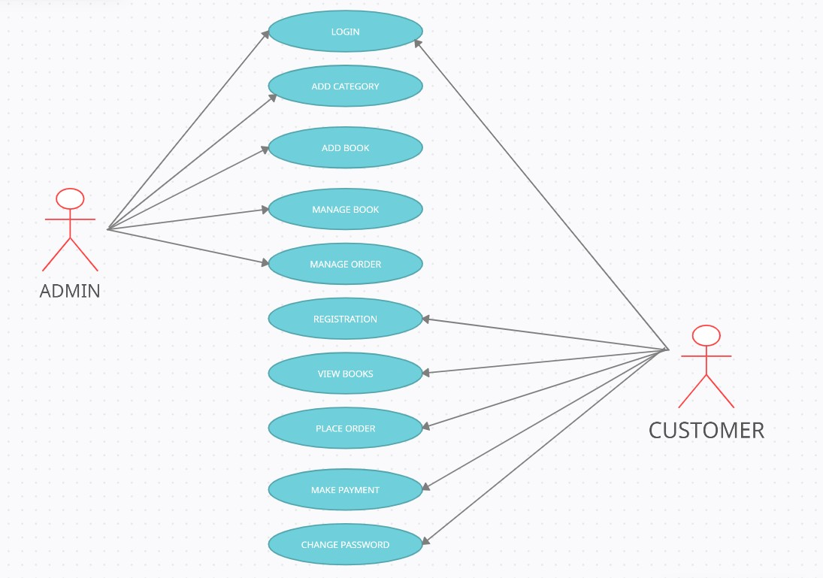

* 1. **Flow Diagram**

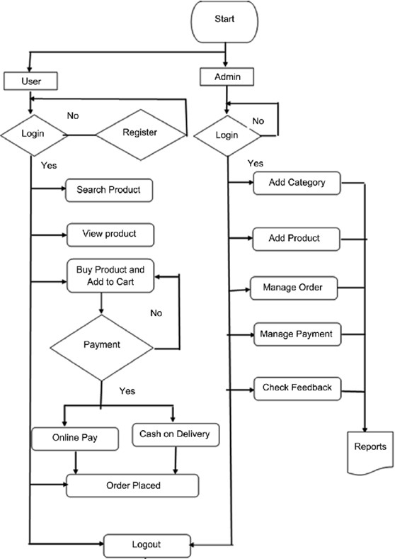

**Chapter 3 Implementation**

Step 1:

Create an EC2 instance .

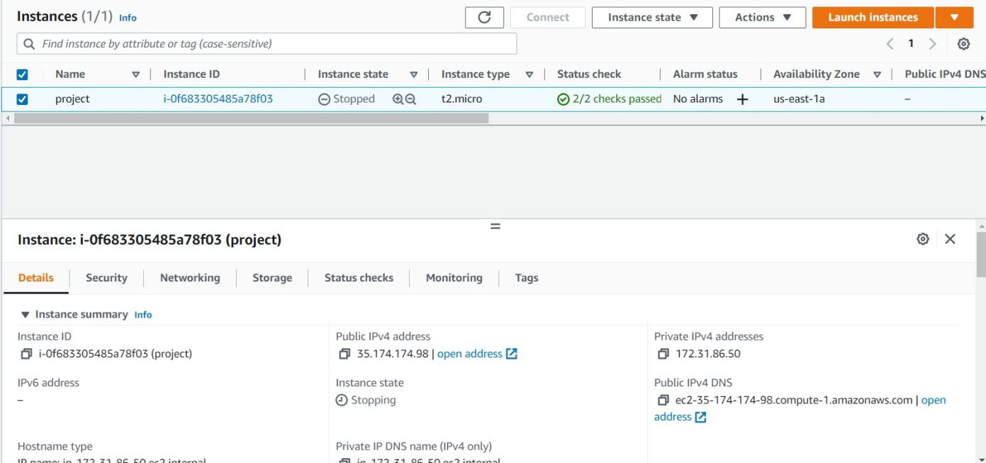

Step 2:

After Status checks are passed click on connect and go to RDP client.Click on get password and decrupt the pem file which you downloaded while creating EC2 instance.

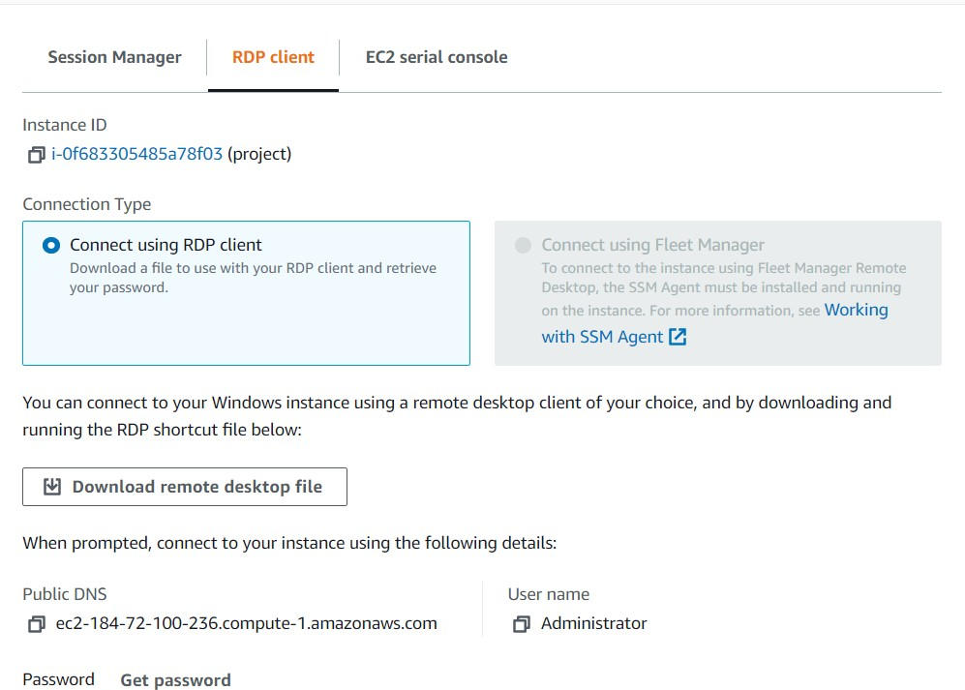

Step 3:

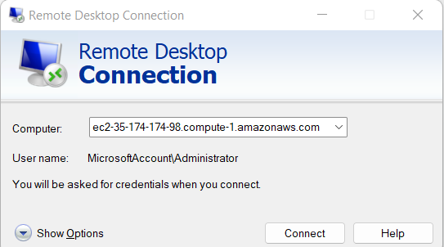Open remote desktop connection and copy the public dns and paste it in the computer section and click on connect.

Step 4

After clicking on connect it moves to window security page from there copy and paste the username and password from RDP client page.

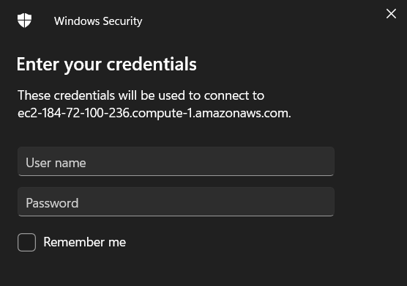

Step 5:

After filling the required credentials now the instances is opened



Step 6:

Now open browser and download XAMPP application in you instance.

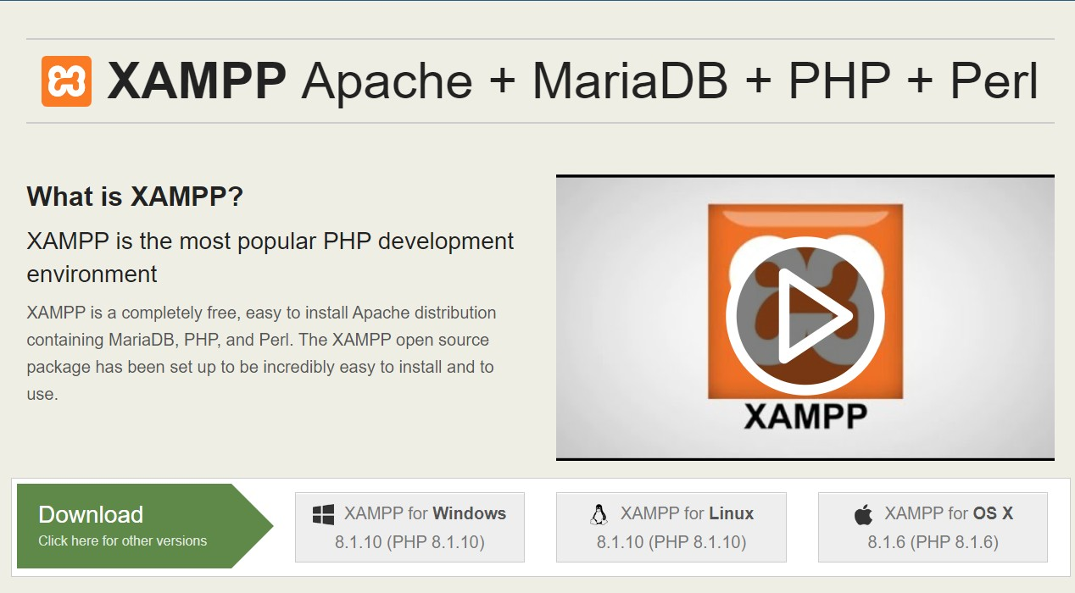

Step 6:

Now open XAMPP file saved in the local disk and click on htdocs

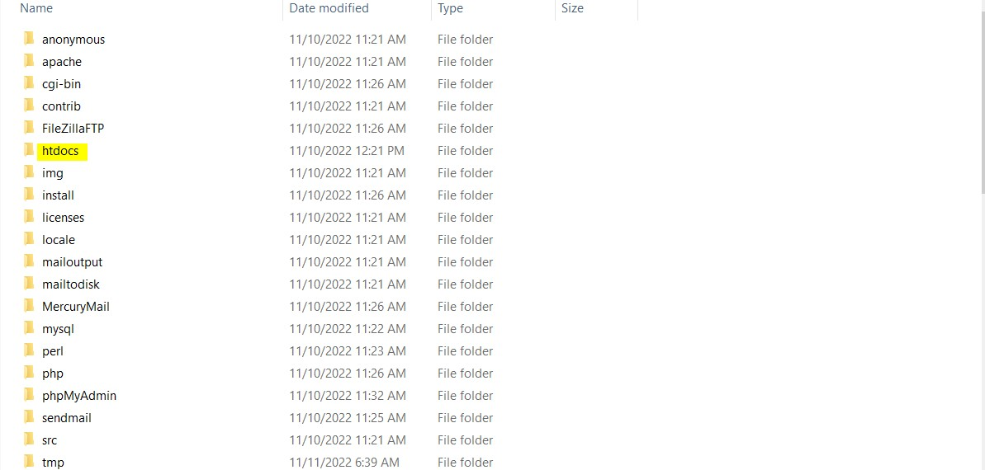

STEP 7:

Now move all your projet html files to this file and rename it has dashboard.

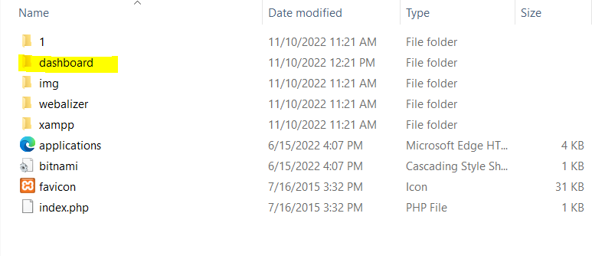

Step 8:

Now open the XAMPP control panel and click on start for apache and the MySQL

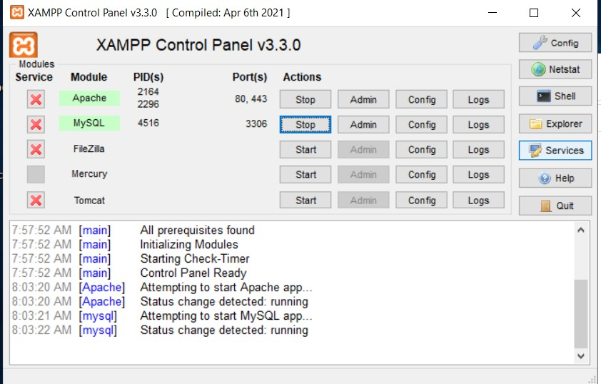

Step 9:

Click on admin in my sql section and you will be redirected to the PHPmyADMIN page.

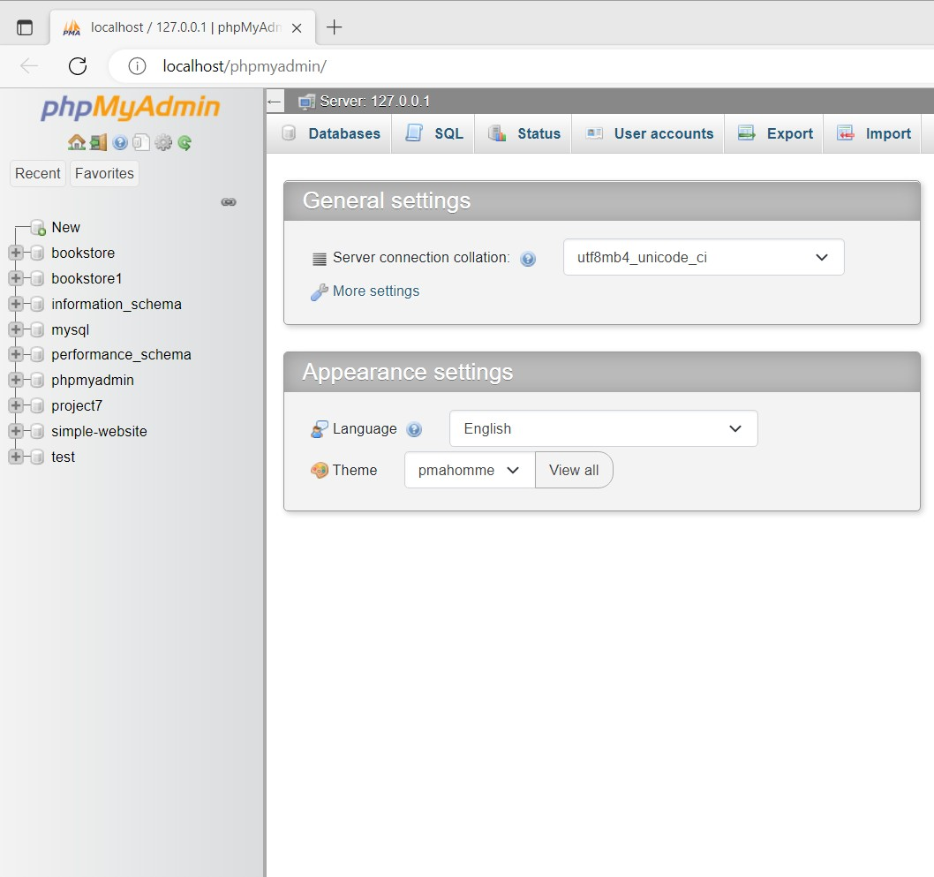

Step 10:

Now open the website which you hosted in the EC2 in new tab.

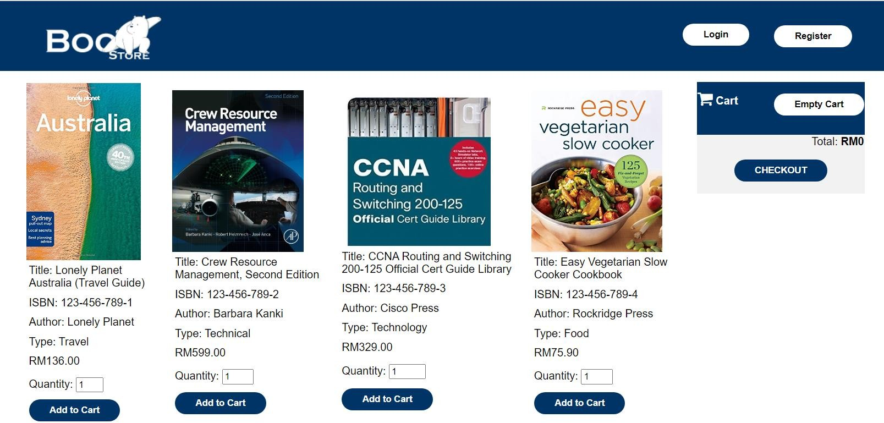

Step 11:

Now click on register or the section where to fill details and fill accordingly.

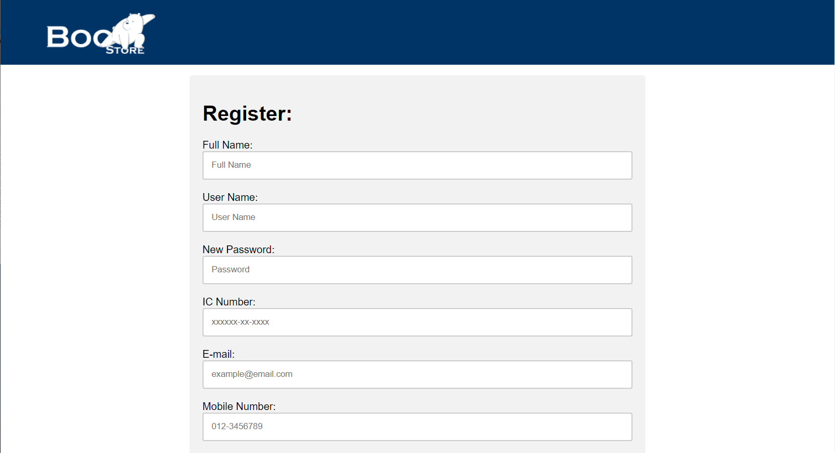

Step 12:

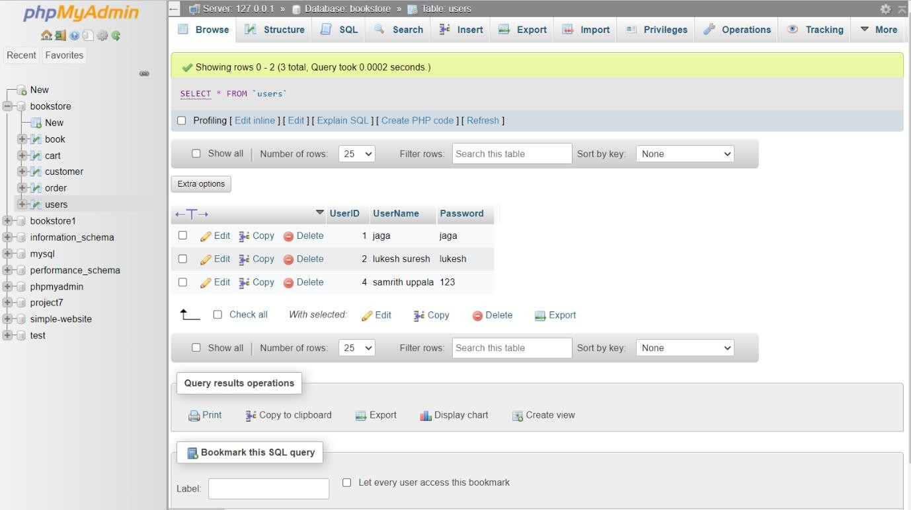After filling the details Go back to the admin page and in the user section you can see all user datas are stored.

**Chapter 4**

**Conclusion**

Thus, we defined the problem statement and provided a solution in which dynamic websites can be run without depending on much storage space. With this method of hosting dynamic website on a virtual instance, it is very convenient and occupies less storage in the server.